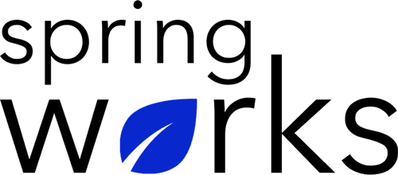
Free Template –Meeting Plan Survey

Use this survey to gain insights into the efficiency of organizational meetings .

Meeting plan is required to analyze the structure and purpose behind the meetings taking place in the organization. Here is a survey to analyze how your employees feel about the procedure:

Communication (to be added as review instructions):

Your responses to this survey are anonymous. The leaders are committed to analyzing your results and taking action. Please answer this quick survey by <HOUR OF THE DAY> on <DATE>.

Thank you for your time. Your responses will help our organization become a better place to work. If you have any questions about the survey, please contact [insert name of contact person].

Demographic Information:

The following information is requested so that meaningful analysis and comparisons of group results can be made. Please check the circle corresponding to your answer.

Q: Your Gender:

- Male
- Female

Q: Your Department:

- Marketing
- Operations
- Tech
- Accounting
- HR

Q: Company Service:

- Under 1 Year
- 1-2 Year
- 3-5 Year
- 6-10 Year
- 10-15 Year
Meeting Plan Questionnaire

To answer clearly what you think or feel about each item, please follow these steps:

- Read each item fully before you start to mark your answer.
- Pick the one answer which most nearly says what you think or how you feel.
- While completing the questions, be sure to read the special instructions which are included.

Choose the most appropriate answer:

Q: Did the meeting achieve the goal behind it:

- Yes
- No
- Maybe

Q: The meeting possessed disciplined and equal communication:

- Strongly agree
- Agree
- Neutral
- Disagree
- Strongly disagree

Q: Are more meetings required for this reason?

- Yes
- Maybe
- No

Q: The timing of the meeting was decided keeping in mind the schedule of the all members invited:

- Strongly agree
- Agree
- Neutral
- Disagree
- Strongly disagree

Q: The meeting landed to a proper conclusion:

- Strongly agree
- Agree
- Neutral
- Disagree
- Strongly disagree

Q: These meetings allow you to interact with each other better:

- Strongly agree
- Agree
- Neutral
- Disagree
- Strongly disagree

Q: Overall, I am satisfied with the meeting:

- Yes
- No
- Can do better

Q: Any area(s) you were completely satisfied with:

i.
ii.
iii.
Q: Any area(s) you were dissatisfied with:

i.
ii.
iii.

Q: Any suggestions for the next meeting’s agenda:

i.
ii.
iii.

